5.48: a) This situation is equivalent to that of Example 5.23 and Problem 5.44, so 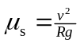. Expressing v in terms of the period T, 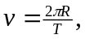 so 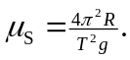 A platform speed of 40.0 rev/min corresponds to a period of 1.50 s, so
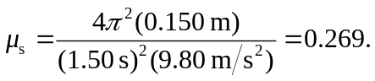
b) For the same coefficient of static friction, the maximum radius is proportional to the square of the period (longer periods mean slower speeds, so the button may be moved further out) and so is inversely proportional to the square of the speed. Thus, at the higher speed, the maximum radius is (0.150 m) 

